Loop detectors

There were 20 loop detectors identified in the area of the research interest and the earliest stage of the research was examination of loop detector data. The daily aggregate flows were computed for each of the detectors and a map of those detectors was plotted. At this stage of the research it was, however, impossible to link the analysis of drivers’ rationality to the loop detector data.

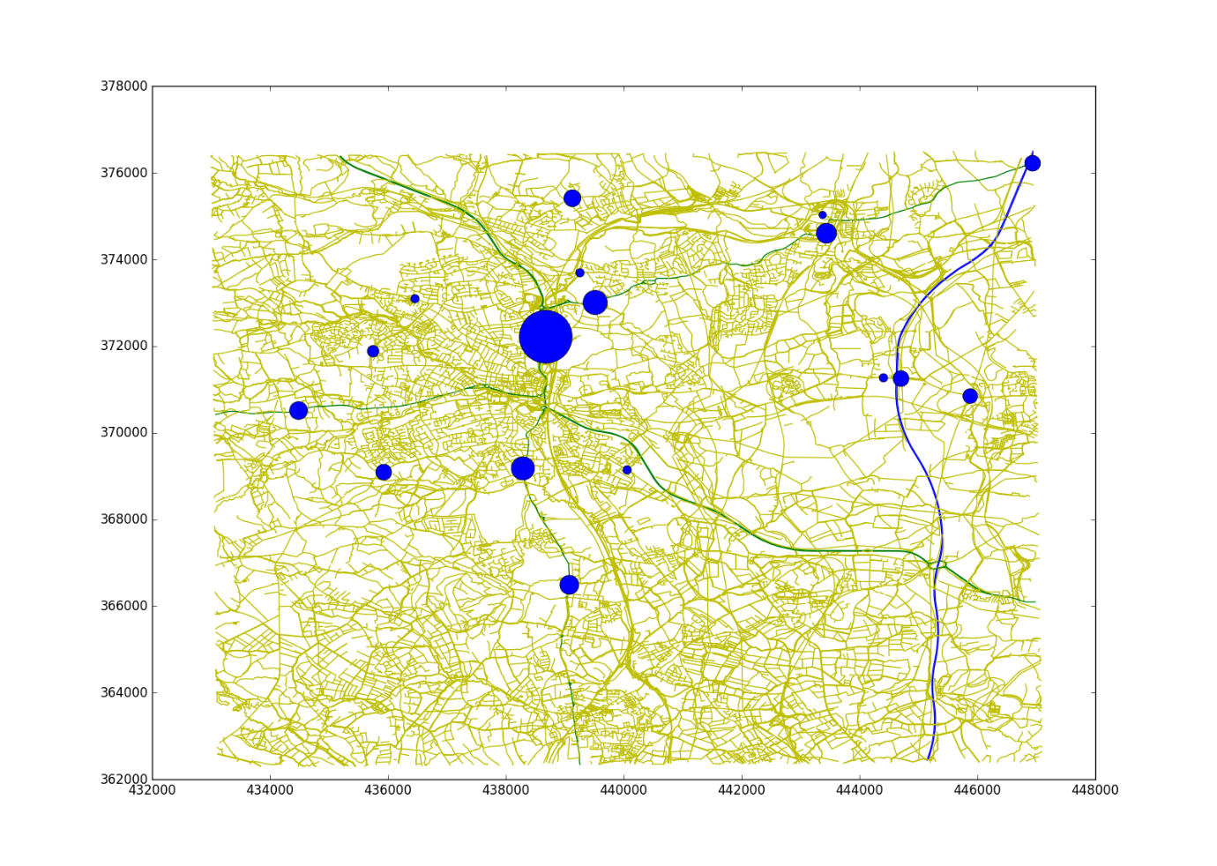

Recommendations?

It would be possible to try to merge data derived from different sources and at different locations in the network. In some further research it may become sensible to try to use loop detector data for validation of data derived from Bluetooth sensors.